1.37: Take the +x-direction to be forward and the +y-direction to be upward. Then the second force has components 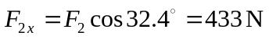and 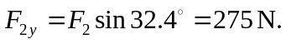 The first force has components 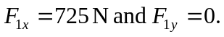
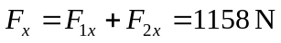 and 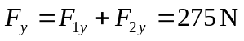

The resultant force is 1190 N in the direction 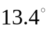above the forward direction.

